Electromagnetic waves
Worksheet 2
Q1. In common
- They all travel at the same speed in a vacuum - the speed of light, which is 3 108 m/s.
- They're all transverse waves with electric and magnetic fields as oscillations.
- They can be reflected, refracted, and diffracted just like any other wave.
- The difference is their wavelength, which is proportional to the amount of energy carried by the waves. The higher the energy, the shorter the wavelength of the radiation.
Q2
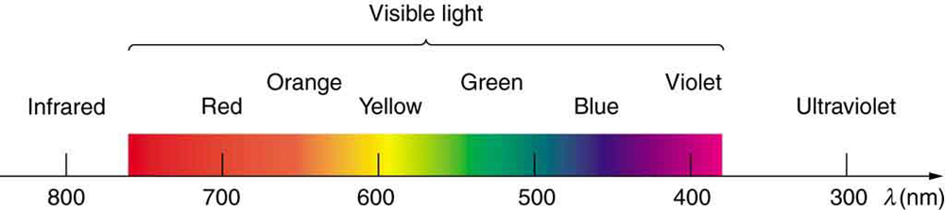

Q3. - Light waves travel in a transverse direction, whereas sound waves travel in a longitudinal direction.
- In a vacuum, light waves may travel. Sound waves cannot move in a vacuum because they require a material medium to travel.
Q4.
Type of EM Wave | Examples of Sources on Earth | Examples of Cosmic Sources | Telescopes used
Radio waves | Broadcast radio and television.  Navigation and air traffic | Radio galaxies  Pulsars | Radio Telescope
Infrared Waves | Sun  Planets  Galaxies | Certain starts  Nebulae | Herschel  WISE  JWST
X-rays | Radon gas  Radioactive elements  Cosmic rays | Neutron stars  Black holes | Astrosat  BeppoSAX  BBXRT  Compton Gamma Ray Observatory

